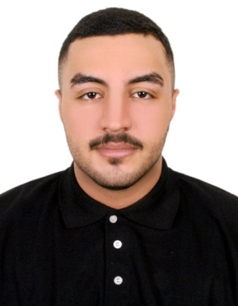

**CURRICULAM VITAE**

ABDULLA SUFYAN SALEH AL FARSHISHI

Personal Profile

**Gender :** Male

**Nationality :** Bahraini

**CPR No :** 000204102

**Date of Birth :** 13-2-2000

Address : FLAT 11 – BLDG 1296 – ROAD – 1814

AL LAWZI – 1018

Marital Status : Single

**Contact No :** 39222503-33122946

**E-mail :** abdulla.sufyan2000@gmail.com

**LICENSE TYPE :** Private🚘

Education

|  |  |  |
| --- | --- | --- |
| 2015 - 2018 | Secondary School  General Certificate  Specialization of Welding & Fabrication | Shaikh Abdullah Bin Isa AL  Khalifa  Technical Secondary School |

Training

|  |  |  |
| --- | --- | --- |
| 2018 | Kitchen Standards Examination Certificate | Jasmi’s Corporation W.L.L. |

**Work Experience**

|  |  |  |
| --- | --- | --- |
| 06/08/2018 06/08/2019 | Jasmi’s Corporation W.L.L. | Promoted from Service Crew to Barista |
| 01/09/2019  30/11/2019 | Coffee Republic | Barista |
| 08/12/2019  29/02/2020 | COSTA COFFEE | Barista |

**Skills**

* Basic computer
* Experience in handling cash & card machine
* Greet customers, record orders, and serve food and beverages with a consistently positive and helpful attitude, including answering questions about the menu.
* Polite and friendly with strong customer service and communication skills.
* Ability to handle multiple demands and stay calm.
* Excellent interpersonal skill and ability to interact with staff at all levels.
* Ability to stand for long hours at a time and work in a fast-paced environment.
* Positive attitude and commitment to customer satisfaction.
* Fast learner, Passionate & hardworking.
* Efficient in handling tasks under pressure.
* Ability to speak & read in English.
* Able to remain calm under pressure.
* Quick, an able and efficient.
* Able to work effectively in a team.

**Hobbies**

Swimming & Playing Taekwondo

## Language

Arabic (mother tongue), English (speak fluently)